18 Best Podcasts for Kids in Elementary, Middle, and High School
Plus related lesson ideas!
Michael Kokias on July 7, 2017

What are the best podcasts for kids to listen to in the classroom? We asked teachers to share their favorites, and here’s what they had to say.
Disclaimer: We’ve divided the list by grade level because some might be more intense or cover more mature topics than is appropriate for younger students. Make sure to vet the podcast and get it cleared by your administrator and/or parents before using them in your class.

Best Podcasts for Kids in Elementary School
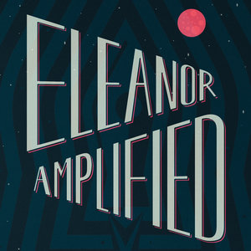
1. The Radio Adventures of Eleanor Amplified
Listen as world-famous radio reporter Eleanor foils devious plots, outwits crafty villains, and goes after The Big Story. Eleanor’s pursuit of truth takes her into orbit, out to sea, and even to the halls of Congress! Her adventures are entertaining and informative.
Activity to try: Have a discussion about Eleanor and her values, especially the importance of access to information, being inclusive to different points of view, and telling the truth. Then have your students write about what their values are.

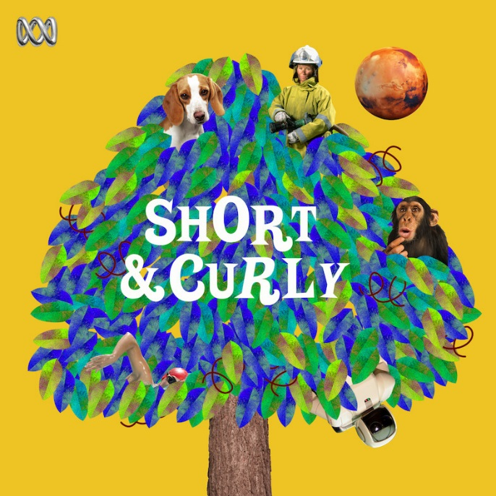
2. Short and Curly

A fun-filled podcast for kids all about ethical questions that get kids and adults thinking. “Do you have to love your sibling?” “Are some lies actually okay?” “Is it ever okay to fight back against a bully?”
Activity to try: Have your students write down questions to which they don’t know the answers, and talk about a few (after vetting them, of course).

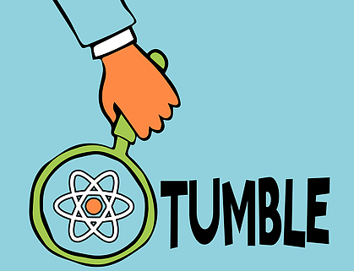
3. Tumble

Science is brought to life in this podcast that tells stories about science discoveries with help from actual scientists. They answer questions from why cats always seem to land on their feet to what a journey to the center of the earth would look like.
Activity to try: Discuss the topic of any given episode as a class, opening it up to questions and encouraging further research.

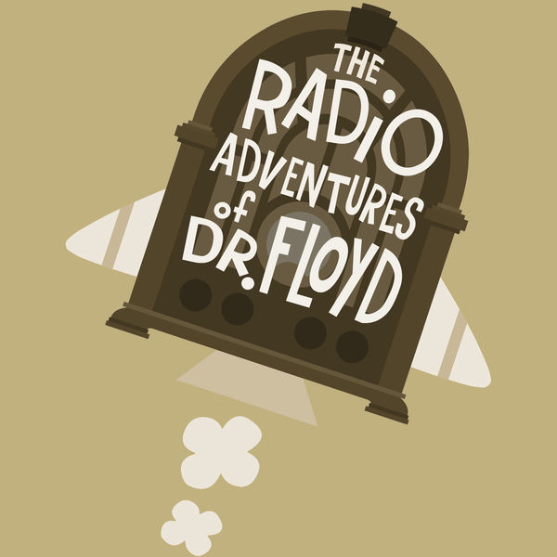
4. The Radio Adventures of Dr. Floyd

Follow the on-going battle between Dr. Floyd and the evil mastermind, Dr. Steve (along with his sock-shaped assistant, Fidgert). During all their fighting, Dr. Floyd learns about history. With more than 400 episodes, there are plenty to choose from.
Activity to try: Have students write their own episode, including a historical event that they love or that you have covered.

5. Brains On!
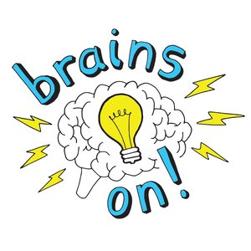
“Brains On!” features science and kids. The host and her kid co-host talk with food scientists and snake handlers, put on plays, write songs, and so much more. It’s a science lesson for your ears!
Activity to try: Listen to the March 23 episode, “Books: How they’re made and how your brain reads them”. Afterward, have a discussion with your class about the many ways that reading is great for them.

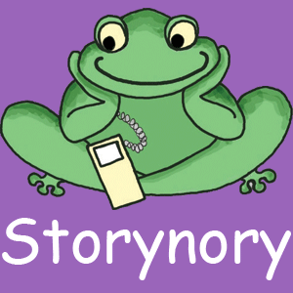
6. Storynory

An online treasure-trove of free audio stories. You can listen to a mixture of original stories, fairy tales, and specially adapted myths and histories. Storynory has published an episode every week since 2005, so there is plenty to love and something for everyone.
Activity to try: Have students write an original short story and then present it to the class.

Best Podcasts for Tweens in Middle School
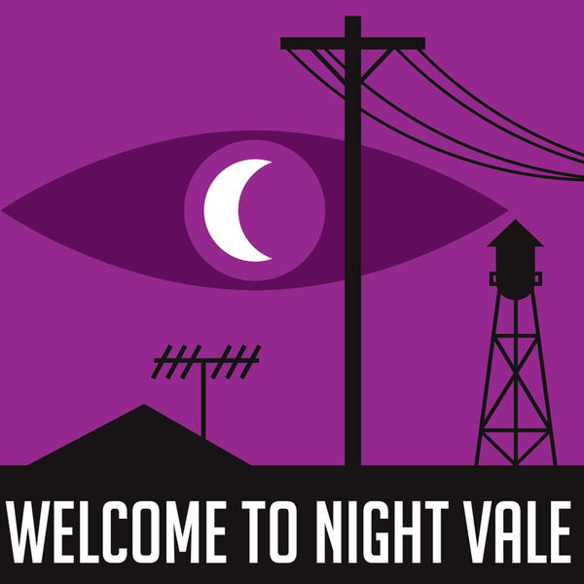
7. Welcome to Night Vale

Tune into the community radio of this desert town for the news on local weather, the mysterious lights overhead, announcements from the Sheriff’s Secret Police, a dog park that prohibits dogs, and dark hooded figures with unknowable powers.
Activity to try: Challenge students with this prompt: You have been hired by the Night Vale Community Radio to write a segment. It could be a continuation of a segment that already exists, like “The Children’s Fun Fact Science Corner” or “Community Calendar,” or a report of a strange happening in the town, told in Cecil-fashion. These could be performed in front of the class, written, or put in podcast form.

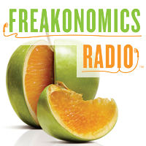
8. Freakonomics Radio

A podcast created by the co-author of Freakonomics and Superfreakonomics, Stephen Dubner invites listeners to explore the hidden sides of everything. And, given his almost 300 episodes on topics ranging from “Millionaires vs. Billionaires” to “How to Win a Nobel Prize,” he is well on his way to talking about everything.
Activity to try: Have students pick an episode and find how it affects their everyday life. These can be written or presented to the class, allowing for discussion and questions.

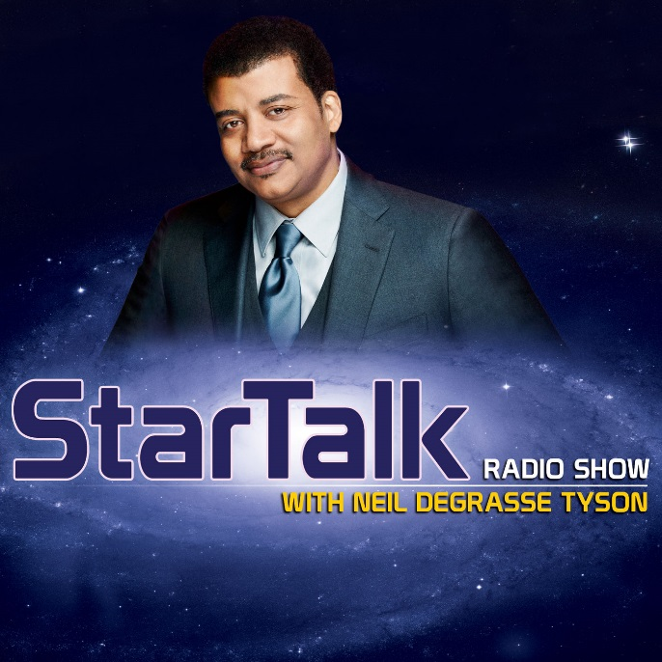
9. StarTalk Radio

Neil deGrasse Tyson talks about all things space: stars, planets, humans in space, and so much more. He also interviews a lot of amazing people, from Buzz Aldrin to Alan Rickman.
Activity to try: Have students research the science topic covered in a given episode, learning more about the topic and sharing their findings.

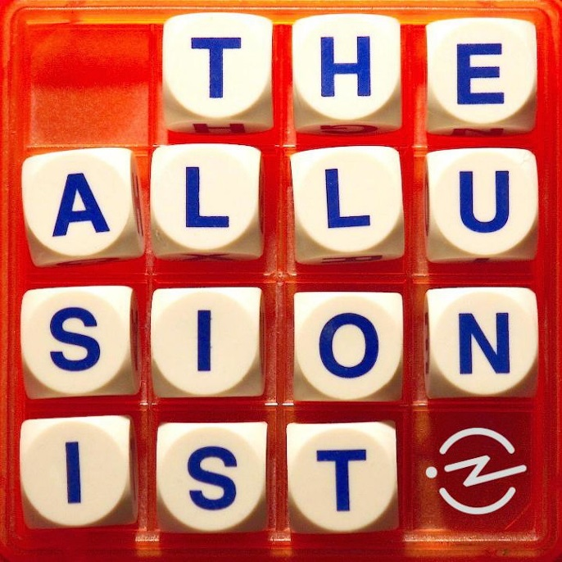

10. The Allusionist

Explore the English language, with all its oddities! Filled with good humor and levity, this podcast will help you explore the roots of words and phrases that we use every day.
Activity to try: Have students write their own grammatical or linguistic jokes, using these as starter examples.

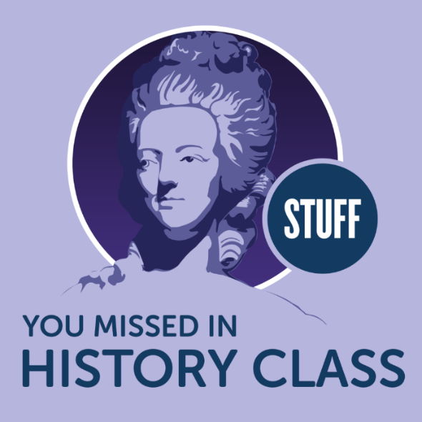

11. Stuff You Missed in History Class

The title speaks for itself. Learn about people and events that are often overlooked in a typical history class.
Activity to try: Choose a popular unit of historical study, like the Civil War or Great Depression, then have students research the little told stories related to it. They could even write a readers theater based on their findings.

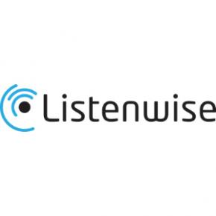
12. Listenwise

Listenwise is an award-winning listening skills platform, searchable by topic area or school subject. It advances classroom learning by providing additional content and building listening skills. There is also a focus on current events that keeps learning tied to the real world.
Activity to try: Each episode comes equipped with teaching resources, so pick the topic that is best for your class and get listening.

Best Podcasts for Teens in High School
13. Serial

Sarah Koenig tells one story, told week by week. The first season covers the true story of Adnan Syed, convicted for the murder of his ex-girlfriend in Baltimore. The problem: Adnan cannot remember what he was doing the day of the murder. And, as if that wasn’t bad enough, there’s someone claiming that he helped Adnan hide the body.
Activity to try: Have students find a famous crime in history and write a dialogue between themselves and the accused, having the accused tell their side of the story. These projects can be handed in, performed in front of the class, or put into podcast format.

14. Radiolab
Radiolab is a show about curiosity. Where sound illuminates ideas, and the boundaries blur between science, philosophy, and human experience.
Activity to try: Listen to the episode “Sight Unseen”about a soldier’s last moments and the photographer who captured them, divide the class in half, and have them prepare and then conduct a debate on whether or not the photographer has the right to publish the photos.

15. Criminal
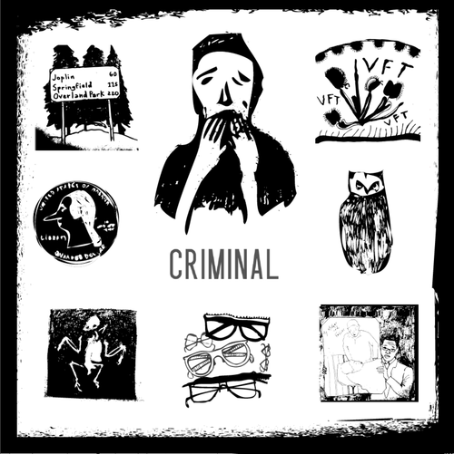
Stories of people who’ve done wrong, been wronged, or gotten caught somewhere in the middle. Phoebe Judge explores topics from owls killing people to “How to fake your death” to the life of a police dog.
Activity to try: Have students pick an episode that interests them and do more in-depth research on the topic, presenting their findings to the class.

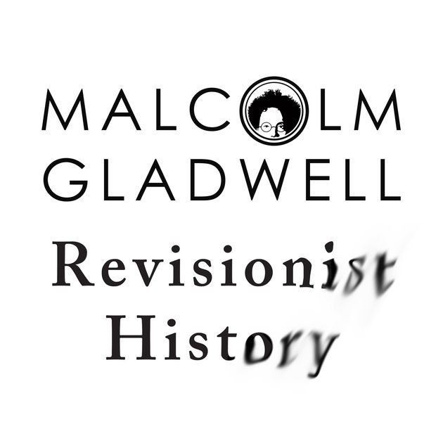

16. Revisionist History

Malcolm Gladwell, author of Outliers and The Tipping Point, looks back through the overlooked and misunderstood in history, re-examining the past and asking whether we got it right the first time.
Activity to try: Listen to the three-part series on college (season one, episodes 4-6), and have a class discussion. Trust me, there will be plenty to talk about.

17. This American Life
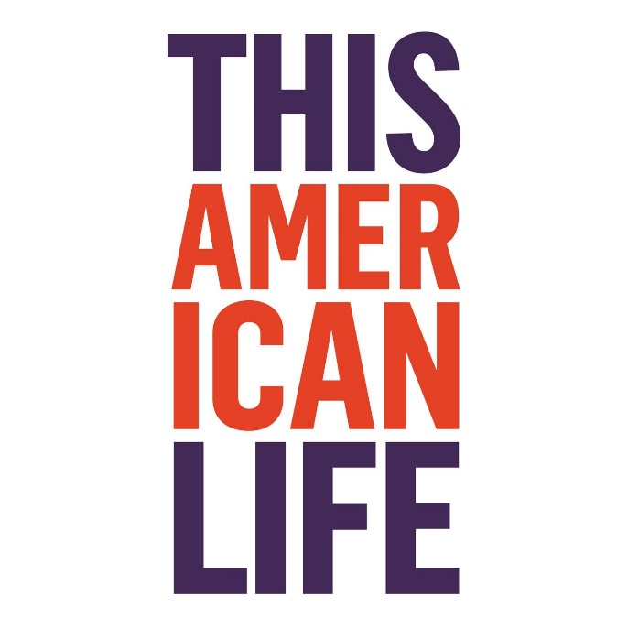
Each episode of This American Life centers around a theme, with most being journalistic at the core, but some are comedic. This podcast is hard to generalize, especially after over 600 episodes. But the amount of episodes, and it’s massive popularity, should speak for itself.
Activity to try: Have students take a theme from an episode and write their own report or story surrounding that theme.

18. Youth Radio
Youth Radio is a podcast for teens, published by teens. It was created to showcase the power of young people as makers of media, technology, and community. It brings the teen perspective to issues of public concern.
Activity to try: Have your students select a topic in the news today and write their own podcast sharing their take on the news.

