Freshman English ~ Root Word Family Tree

- Go to www.membean.com/treelist and check out the word families. By clicking on the root you will be able to see a tree that shows several words that share the root.
*Note: the words with dashes are prefixes and suffixes. The root words do not have dashes. Make sure that you are choosing a root word and not an affix.
- Choose one root to use for your own root word tree.
- Using construction paper and a template, cut out your tree trunk, leaves, apples and rectangles.
- Your tree must include at least five (5) words that share a common root.
- Define your root and glue it to the roots of the tree. See example below:
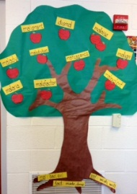

- For each word in the root family, write the word on the rectangular piece of paper. Write the definition on the apple.
- Arrange and glue the words and their definitions to your tree.
- Please make sure that your name and class period are on the back of your tree.
- Due Tuesday January 28.

